홀짝 게임 과제

실행화면
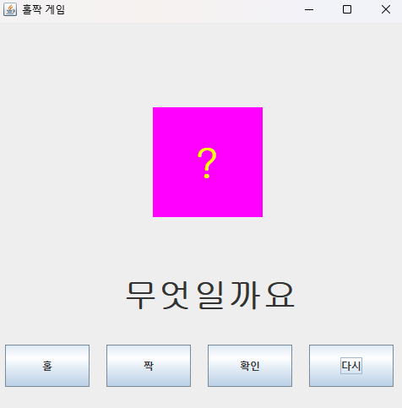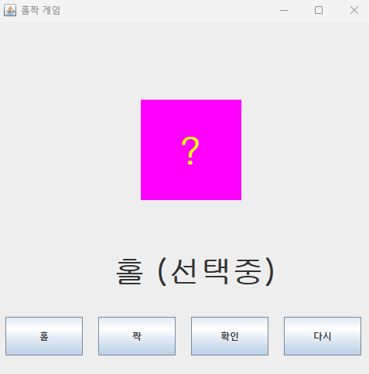
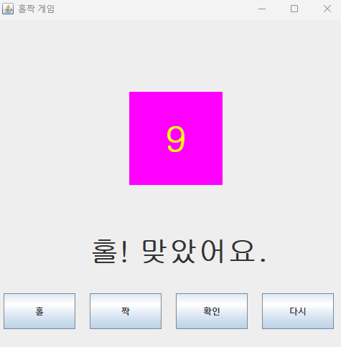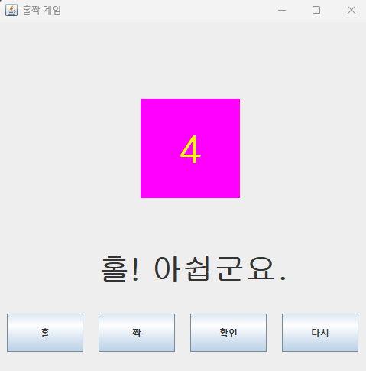

소스코드
Main.java
package selectOddEven;
public class Main {
public static void main(String[] args) {
swing s = new swing();
}
}

logic.java
package selectOddEven;
public class logic {
public String selectOdd() {
return "홀";
}
public String selectEven() {
return "짝";
}
public boolean selectAnswer(int rNumber, String select) {
if (select.equals("홀")) {
if (rNumber % 2 == 1) {
return true;
}
else return false;
}
else if (select.equals("짝")) {
if (rNumber % 2 == 0) {
return true;
}
else return false;
}
else {
System.out.println("Error!");
return false;
}
}
public int makeRandomNumber () {
int rNumber = (int)(Math.random() * 10) + 1;
return rNumber;
}
}

swing.java
package selectOddEven;
import java.awt.*;
import java.awt.event.*;
import javax.swing.*;
class swing extends JFrame {
private CenterPanel CPanel;
private SouthPanel SPanel;
private logic gameLogic = new logic();
swing() {
super("Multiple Panels and Layouts");
setTitle("홀짝 게임");
setDefaultCloseOperation(JFrame.EXIT_ON_CLOSE);
setSize(500, 500);
//setContentPane(new panel());
Container c = getContentPane();
CPanel = new CenterPanel();
SPanel = new SouthPanel(CPanel, gameLogic);
c.setLayout(new BorderLayout());
c.add(CPanel, BorderLayout.CENTER);
c.add(SPanel, BorderLayout.SOUTH);
setVisible(true);
}
}
class CenterPanel extends JPanel {
public JLabel rNumberLabel = new JLabel("?");
public JLabel stateLabel = new JLabel("무엇일까요");
CenterPanel() {
labelSetting();
add(rNumberLabel);
add(stateLabel);
}
public void labelSetting() {
setLayout(null);
setPreferredSize(new Dimension(500, 410));
Font font1 = new Font("Gulim", Font.BOLD, 50);
Font font2 = new Font("Gulim", Font.BOLD, 40);
rNumberLabel.setFont(font1);
stateLabel.setFont(font2);
rNumberLabel.setForeground(Color.YELLOW);
rNumberLabel.setBounds(235, 135, 70, 70);
stateLabel.setBounds(150, 300, 300, 50);
}
public void paintComponent (Graphics g) {
super.paintComponent(g);
g.setColor(Color.magenta);
g.fillRect(185, 100, 130, 130);
}
}
class SouthPanel extends JPanel implements ActionListener {
JButton oddButton = new JButton("홀");
JButton evenButton = new JButton("짝");
JButton selectButton = new JButton("확인");
JButton restartButton = new JButton("다시");
private CenterPanel cp;
private logic gameLogic;
private String labelPrint = "";
SouthPanel(CenterPanel CPanel, logic gameLogic) {
this.cp = CPanel;
this.gameLogic = gameLogic;
setLayout(null);
setPreferredSize(new Dimension(500, 90));
ButtonSetting();
addListeners();
add(oddButton);
add(evenButton);
add(selectButton);
add(restartButton);
}
public void ButtonSetting () {
oddButton.setBounds(10, 10, 100, 50);
evenButton.setBounds(130, 10, 100, 50);
selectButton.setBounds(250, 10, 100, 50);
restartButton.setBounds(370, 10, 100, 50);
}
private void addListeners() {
oddButton.addActionListener(this);
evenButton.addActionListener(this);
selectButton.addActionListener(this);
restartButton.addActionListener(this);
}
@Override
public void actionPerformed(ActionEvent e) {
Object source = e.getSource();
if (source == oddButton || source == evenButton) {
clickOddOrEven(source);
} else if (source == selectButton) {
clickSelect();
} else if (source == restartButton) {
clickRestart();
}
}
private void clickOddOrEven (Object source) {
cp.labelSetting();
if (source == oddButton) {
labelPrint = gameLogic.selectOdd();
cp.stateLabel.setText("홀 (선택중)");
}
else if (source == evenButton) {
labelPrint = gameLogic.selectEven();
cp.stateLabel.setText("짝 (선택중)");
}
}
private void clickSelect() {
if (labelPrint.isEmpty()) {
cp.stateLabel.setBounds(100, 300, 500, 50);
cp.stateLabel.setText("먼저 선택하세요");
return;
}
int rNumber = gameLogic.makeRandomNumber();
cp.rNumberLabel.setText(Integer.toString(rNumber));
cp.stateLabel.setBounds(130, 300, 500, 50);
if (gameLogic.selectAnswer(rNumber, labelPrint)) {
if (rNumber == 10) {
cp.rNumberLabel.setBounds(220, 135, 70, 70);
}
cp.stateLabel.setText(labelPrint + "! " + "맞았어요.");
} else {
cp.stateLabel.setText(labelPrint + "! " + "아쉽군요.");
}
oddButton.setEnabled(false);
evenButton.setEnabled(false);
selectButton.setEnabled(false);
}
private void clickRestart() {
labelPrint = "";
cp.rNumberLabel.setText("?");
cp.stateLabel.setText("무엇일까요");
cp.labelSetting();
oddButton.setEnabled(true);
evenButton.setEnabled(true);
selectButton.setEnabled(true);
}
}

